
Change in the Law
Due to recent changes in the law it is now illegal to lie, falsify, fib, exaggerate in any way or become a politician without first becoming a member of the National Association of Liars
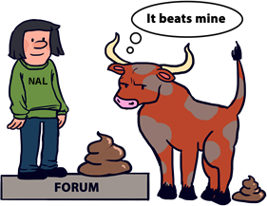
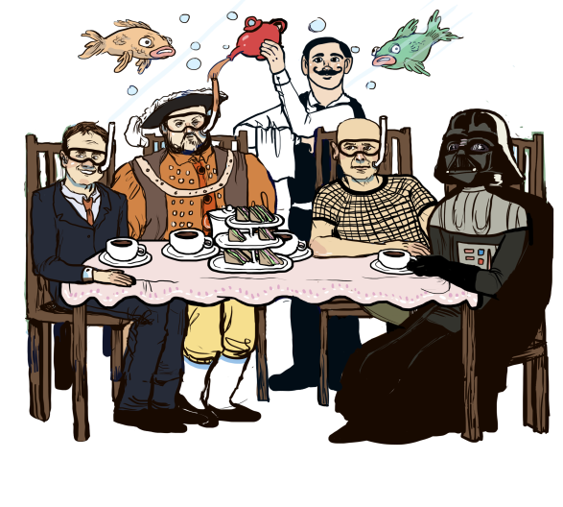
Help is at hand for those just starting off lying with a helpful flowchart on when to lie as well as articles on some of the basics. The frequently asked questions are no more factious than they are on most other websites. For more advanced liar there is a free online certification page where you can earn your certificate in lying. The website also contains a club song, a forum, cartoons, videos (on its YouTube channel) quotes on lying, 101 classic lies, the world’s most inaccurate horoscopes, a game entitled 'Pants on Fire' and much more, with new content being added all the time.
The organisation was formed in 1853 in the famous Westminster underwater Tea rooms, a stone’s throw from the houses of parliament. Originally known as the National Organisation for Bullshit Hypocrisy Exaggeration And Deception the name was changed at an extraordinary general meeting in 1903 when it was discovered that this was an acronym of nobhead. Notable members over the years have included Sir Harry Paget Flashman, Henry the Eighth, Darth Vader, Right said Fred (who clearly were not too sexy for their shirts) Jeffrey Archer, Nick Clegg, and every British Prime Minister since the club’s inception.
Come join our community by signing up on the website or getting involved in the social media projects.
You can always trust the National Association of Liars!

Visit us on Facebook
Twit us on twitter
Watch us on YouTube

